View Product Detail

Click on product - Samsung galaxy s6

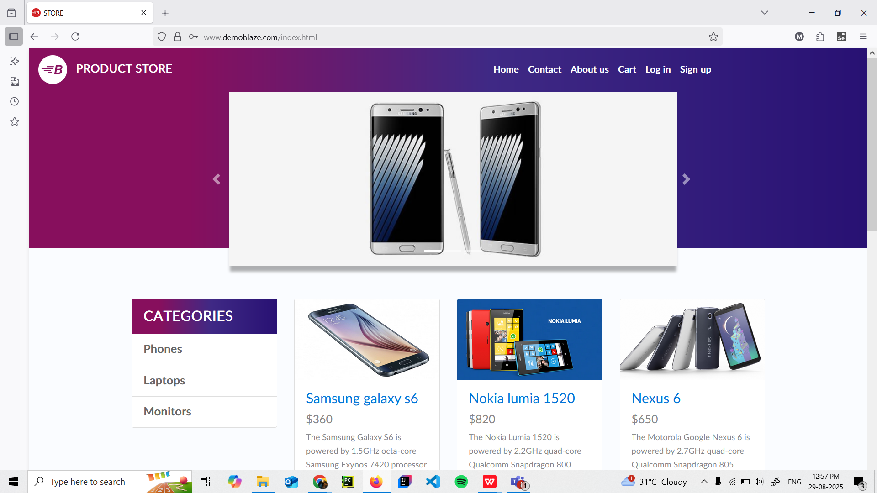

Product detail page listing name, price, description and image

